Let
1291 Main St, Wakefield
do the cooking Wednesday, October 19th from 5-8 pm while 20% of your dinner bill goes to help the
Melrose High School Boys Soccer Team.
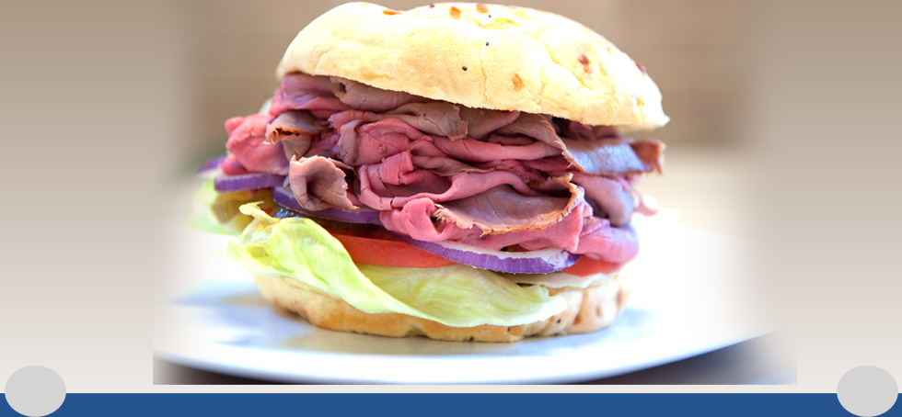

Please present this flyer, October 19th from 5-8pm, to the folks at Billy’s and they will generously give 20% back to the Boys High School Soccer Team.
Have a fantastic dinner
&
Thank You for your support!

